RSS Usage Manual

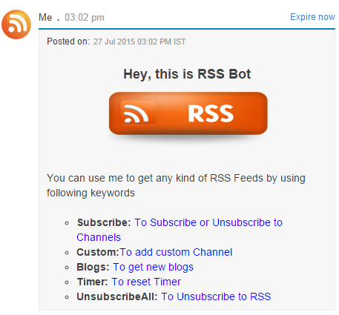
“help” keyword initiates the bot and gives the list of keyword which can be used to perform various activities.

To subscribe to any of the channels use the subscribe keyword to subscribe from the given list.
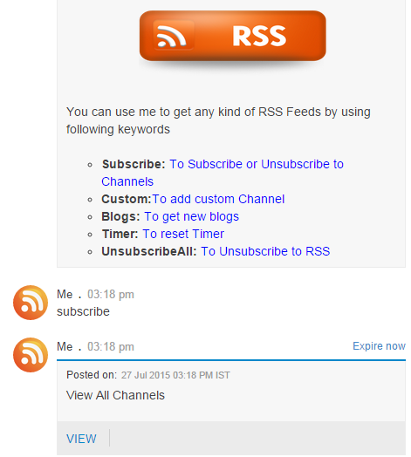
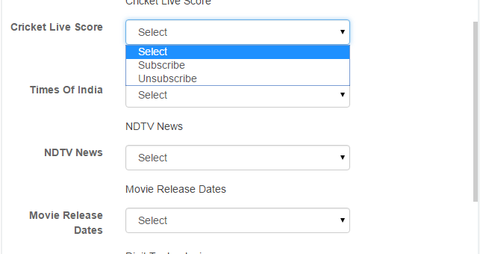

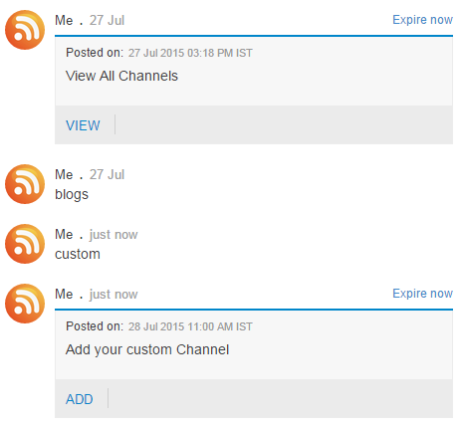
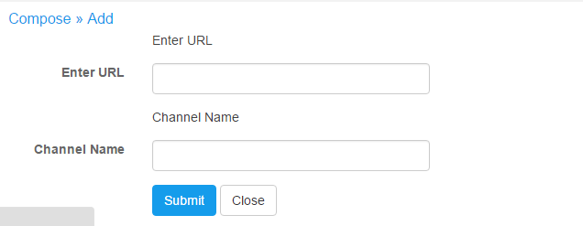
To subscribe to a custom channel which is not a part of list use the “custom” keyword which asks user to enter the URL and channel name and then you will start receiveng feeds.

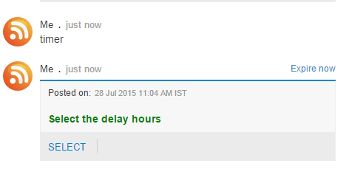
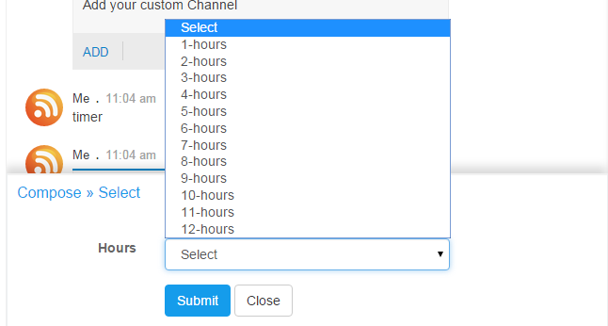
To set the frequency of notification you can use the “timer” keyword and set the timer.

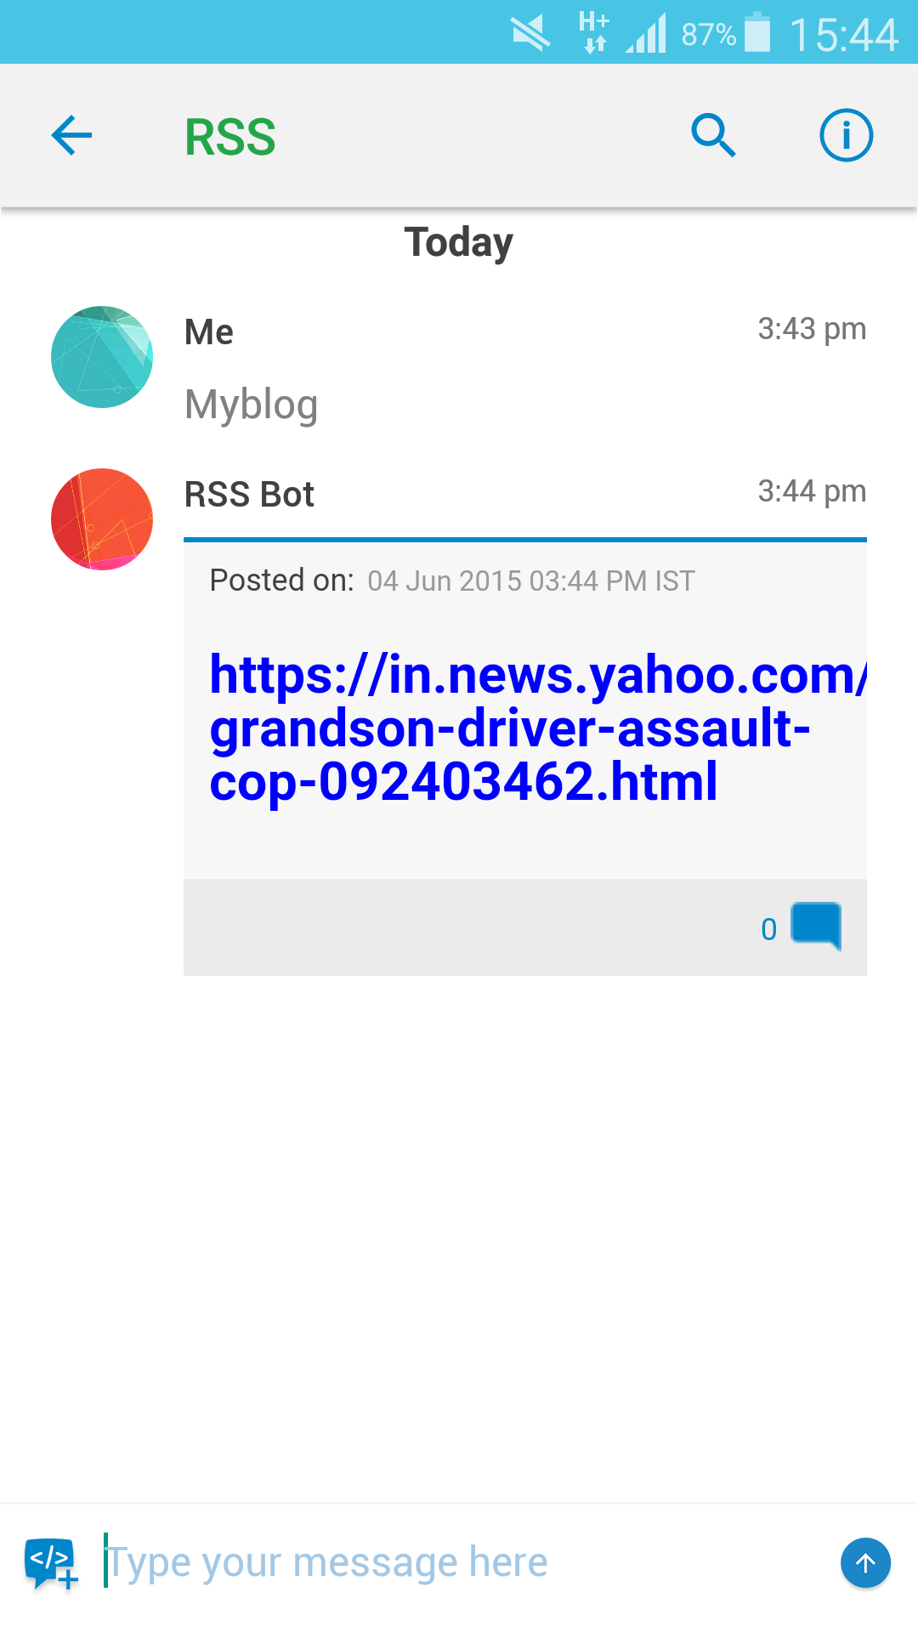
To view blogs of subscribe channel before the timer you can use the “blog” keyword.

To unsubscribe from all the channels use the “unsubscribeAll” keyword

